Point at Site | Position | Date and time Warning Notices were attached to site
Access A  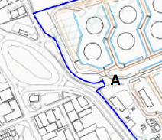 | 1x Warning Notice located at access point A
Gate behind the Refreshment Rooms  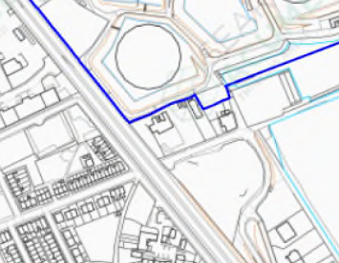 | 1x Warning Notice located at gates behind the Refreshment Rooms
Pedestrian access and gate from the wasteland leading onto the site  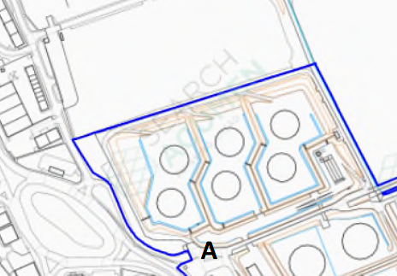 | 1x Warning Notice attached to gate at the pedestrian access from the adjacent land leading onto the site

